A picture containing clipart

Description generated with very high confidence

Hands-on

Installing Kubernetes

DevOps Training

[**support@intellipaat.com**](mailto:support@intellipaat.com)

**+91-7022374614**

**US: 1-800-216-8930(Toll Free)**

Kubernetes Installation

**Step 1: Launch 2 instances with the following configuration:**

**ubuntu 20.04 ami, t2.medium, sg: all traffic.**

**ubuntu 20.04 ami, t2.micro , sg: all traffic.**

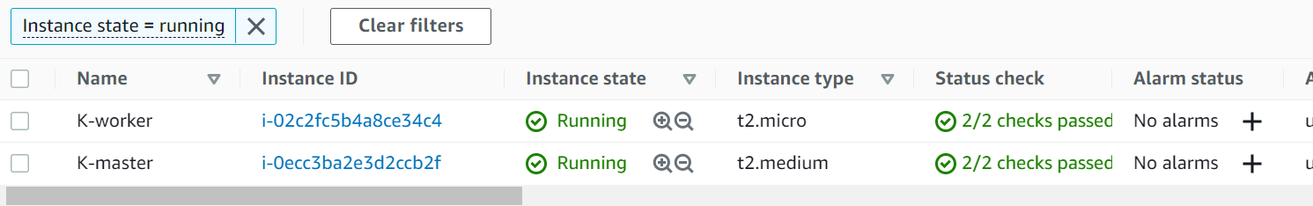

**To Install Kubernetes use the following commands:**

[**https://kubernetes.io/docs/setup/production-environment/tools/kubeadm/install-kubeadm/**](https://kubernetes.io/docs/setup/production-environment/tools/kubeadm/install-kubeadm/)

[**k**](https://stackoverflow.com/questions/52119985/kubeadm-init-shows-kubelet-isnt-running-or-healthy)

**On Master & worker node**

**sudo su**

**apt-get update**

**apt-get install docker.io –y**

**add docker group n give permissions to ur user**

**service docker restart**

**curl -s https://packages.cloud.google.com/apt/doc/apt-key.gpg | apt-key add -**

**echo "deb http://apt.kubernetes.io/ kubernetes-xenial main" >/etc/apt/sources.list.d/kubernetes.list**

**apt-get update**

**apt install kubeadm=1.20.0-00 kubectl=1.20.0-00 kubelet=1.20.0-00 -y**

[**https://kubernetes.io/docs/setup/production-environment/tools/kubeadm/create-cluster-kubeadm/**](https://kubernetes.io/docs/setup/production-environment/tools/kubeadm/create-cluster-kubeadm/)

**Step 2) On both master and worker node run the above command.**

**2.1) sudo su**

**2.2) create a script file k.sh**

**2.3) To execute the script file: bash k.sh**

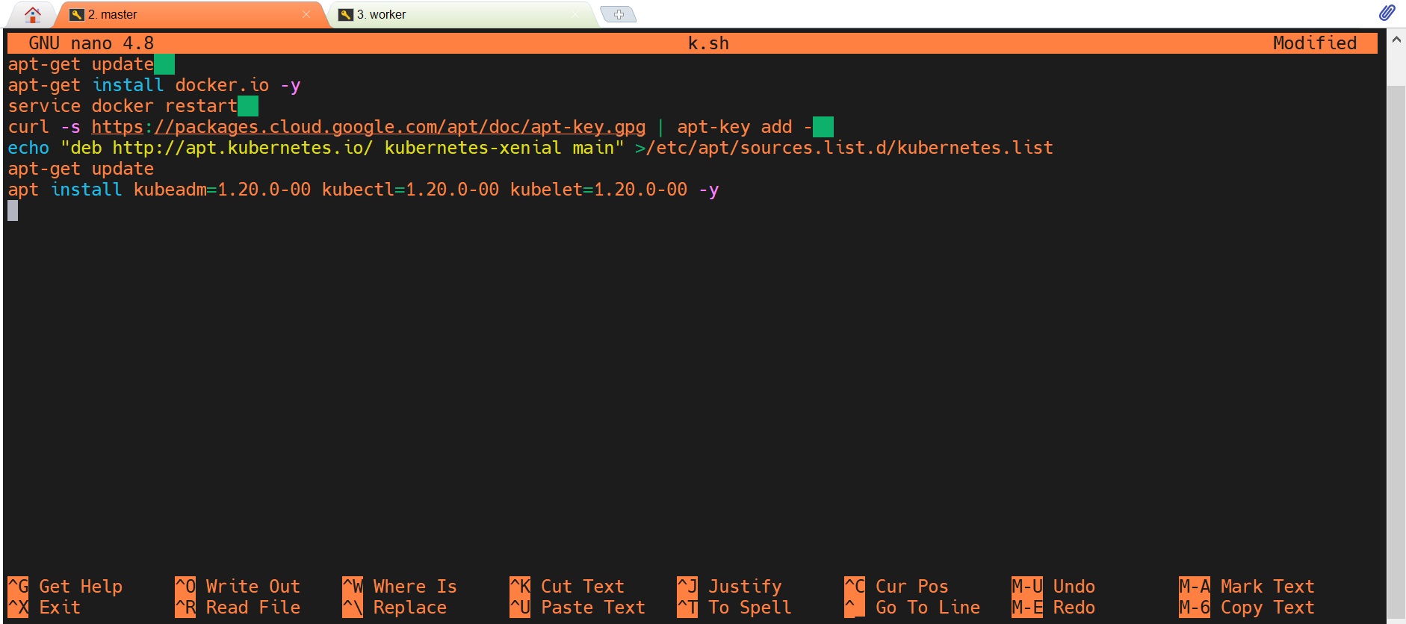

**On Master:**

**Step 3) kubeadm init --apiserver-advertise-address=172.31.28.128 --pod-network-cidr=192.168.0.0/16**

**kubeadm init --apiserver-advertise-address=172.31.28.128 --pod-network-cidr=192.168.0.0/16 --ignore-preflight-errors=FileAvailable--etc-kubernetes-manifests-kube-apiserver.yaml --ignore-preflight-errors=FileAvailable--etc-kubernetes-manifests-kube-controller-manager.yaml --ignore-preflight-errors=FileAvailable--etc-kubernetes-manifests-kube-scheduler.yaml --ignore-preflight-errors=FileAvailable--etc-kubernetes-manifests-etcd.yaml**

**[init] Using Kubernetes version: v1.23.2**

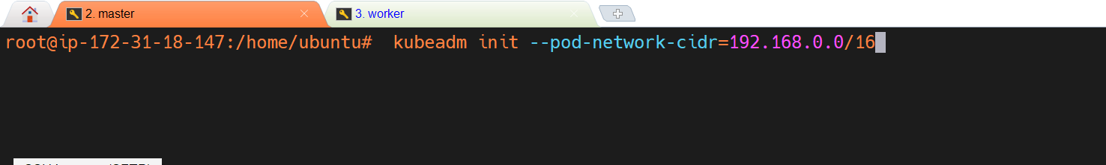

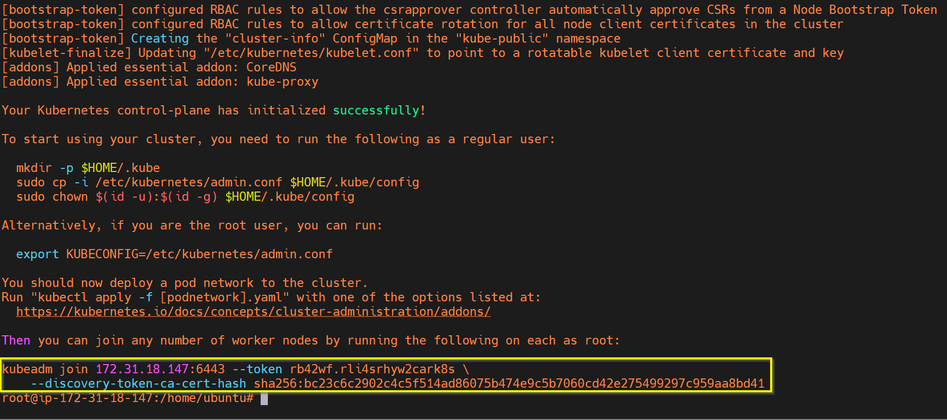

**Copy the token and paste it into the worker node.**

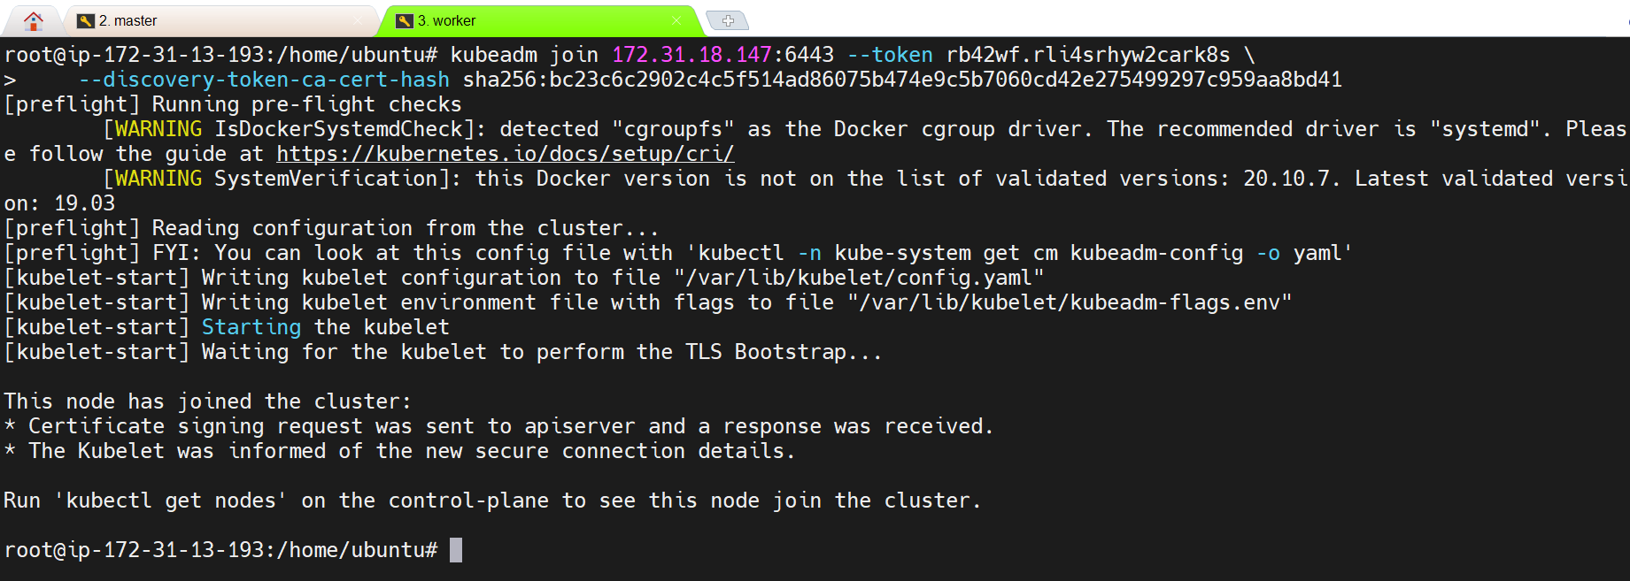

**Step 4)**

**On Master:**

**exit**

**mkdir -p $HOME/.kube**

**sudo cp -i /etc/kubernetes/admin.conf $HOME/.kube/config**

**sudo chown $(id -u):$(id -g) $HOME/.kube/config**

**Note: In case we want to retrieve the join token use the below-mentioned command.**

**kubeadm token create --print-join-command**

**Step 5)**

**On Master:**

**kubectl apply -f** [**https://docs.projectcalico.org/manifests/calico.yaml**](https://docs.projectcalico.org/manifests/calico.yaml)

**kubectl apply -f https://raw.githubusercontent.com/kubernetes/ingress-nginx/controller-v0.49.0/deploy/static/provider/baremetal/deploy.yaml**

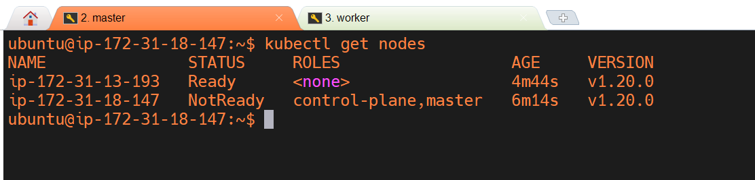

**Our Kubernetes installation and configuration are complete**